[Horse Animset Pro 4.0.1](https://assetstore.unity.com/packages/3d/characters/animals/horse-animset-pro-riding-system-79902?aid=1100lHT6&utm_source=aff)

Publisher: [MalberS Animations](https://www.assetstore.unity3d.com/en/#!/search/page=1/sortby=relevance/query=publisher:16163?aid=1100lHT6)

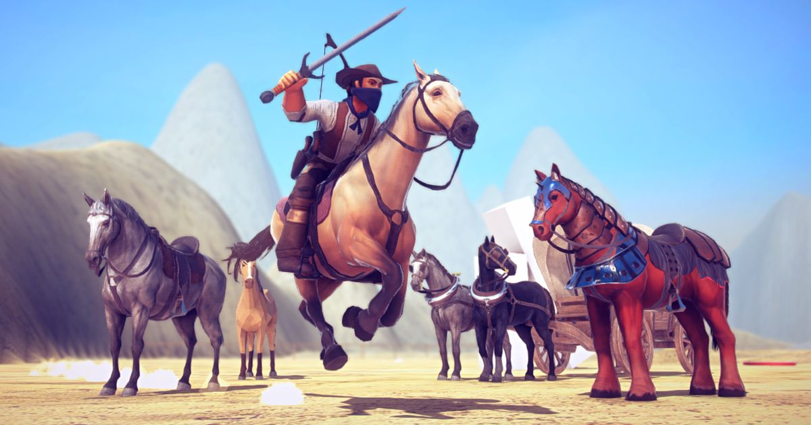

AAA ANIMATIONS

ANIMAL CONTROLLER INCLUDED

(This version use Unity 2018.3.2 and above )

### 

### INDEX

INDEX

Overview

Features

Horse

Rider

General

The Art

Horses

Rider

Western Wagon

Weapons

The controller

Animal

Mount

Parameters General:

Mount Triggers

Parameters:

The Rider

Quick Setup guide (Rider 3rd Person)

The Parameters

Quick Notes

Rider Combat (Combat System while riding)

Quick Setup guide (Rider Combat)

The Parameters

The Weapons

Common Properties:

MMelee

MGun

It uses the IGun interface which inherit from IMWeapon interface.

MBow

MArrow

The Extras

Step Manager & Step Triggers

IK Reins

Mobile Controls

Utility Scripts

Index

# Overview

The Horse AnimSet Pro is an animation framework and Riding System controller, root-motion based for any humanoid character and any game.

This Asset started like a simple Horse model and animation pack, but it has evolved in a strong and flexible Riding Controller.Even though includes a basic character controller from the standard assets, is meant to be used with a more Advanced Character controller created by you or any of the amazing Character controller from the store TCP or FPS.

## Features

### *Horse*

* +80 Animations Clips
* 4 Horse Styles (3 Realistic, Poly Art, MineCraft)
* Several Textures Sets for each horse Style
* LODs
* Armor and Saddle
* Unity Cloth Simulation for the Reins and Mane
* Sounds
* Basic Step System (Track Sound and Tracks particles )
* Animal Controller for managing all Malbers Animations creatures
* Abilities: Swim, Fall, Jump, Attack, Death, Walk, Trot, Canter, Gallop, Sprint
* Directional Damage System
* Camera Base Input
* Terrain Alignment
* Supports NavMesh Agents. Basic AI

### *Rider*

* 132 Animation Clips (Meant to be used with Humanoid Rigs for better compatibility)
* Cowboy Model with 1 Texture Set
* Rider System (TCP & FPS)
* Rider Combat System: Bow, Pistol, Melee (*next: Spear, Rifle, Magic Staff, Throwables*)
* Compatibility with mayors TCP Controllers on the Unity AssetStore (Ootii, Invector, Opsive, UFPS)
* Very very veeeery Basic Inventory system just to demonstrate the compatibility of the Rider Combat System with external Inventory Systems;

### *General*

* Utility Scripts for making life much easier
  + Material Changer
  + Blend Shapes
  + Meshes Changer
  + Animator Message Behaviour
  + Animator Sound Behaviour
  + Head Track
* Weapons(Models, Textures and Scripts)
* Animal Basic AI
* Basic Camera Rig System with camera states.

# 

Index

# The Art (pending)

## Horse

### Meshes:

Body:  
Mane

Reins

Saddle

Armor

## 

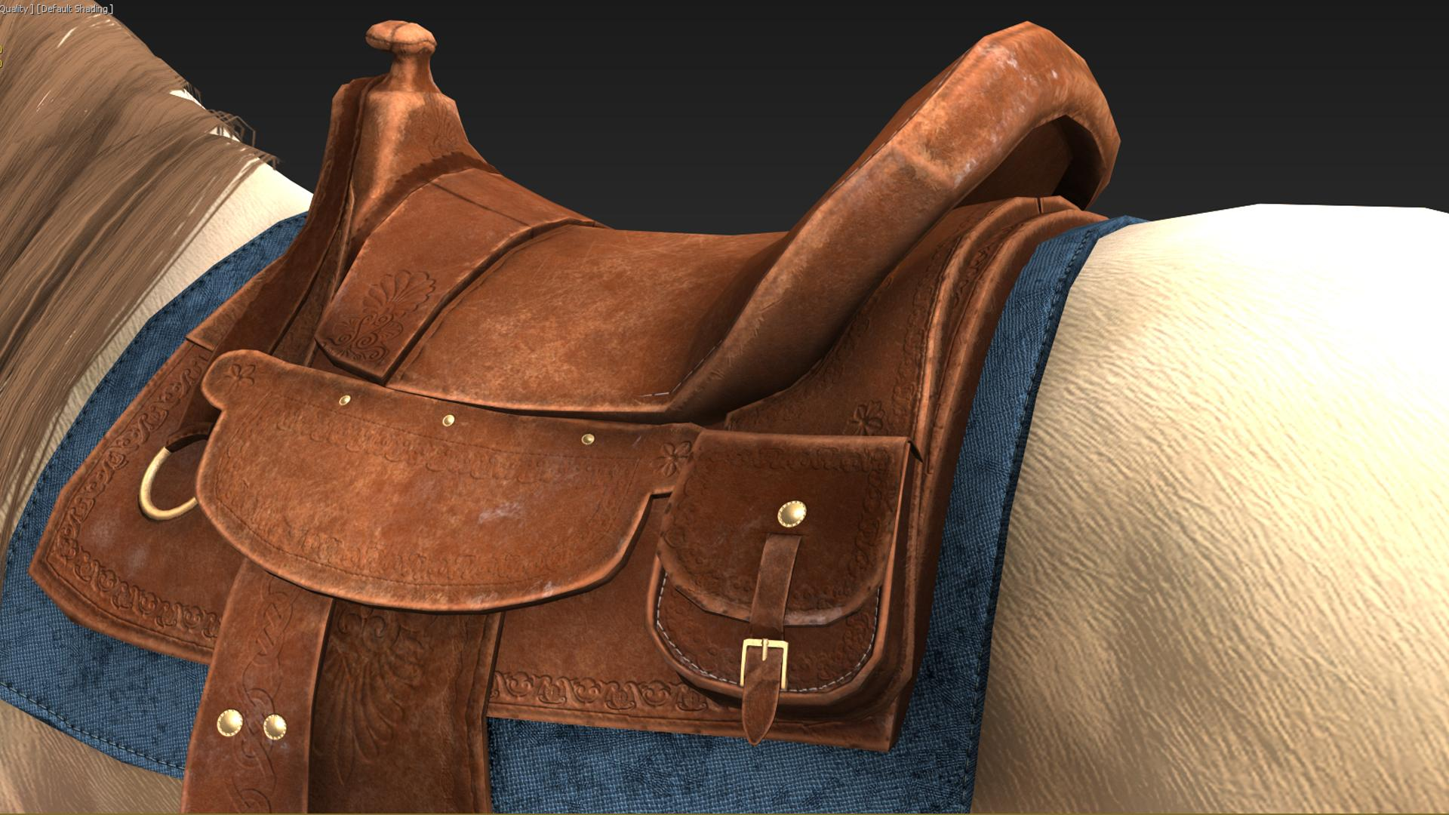

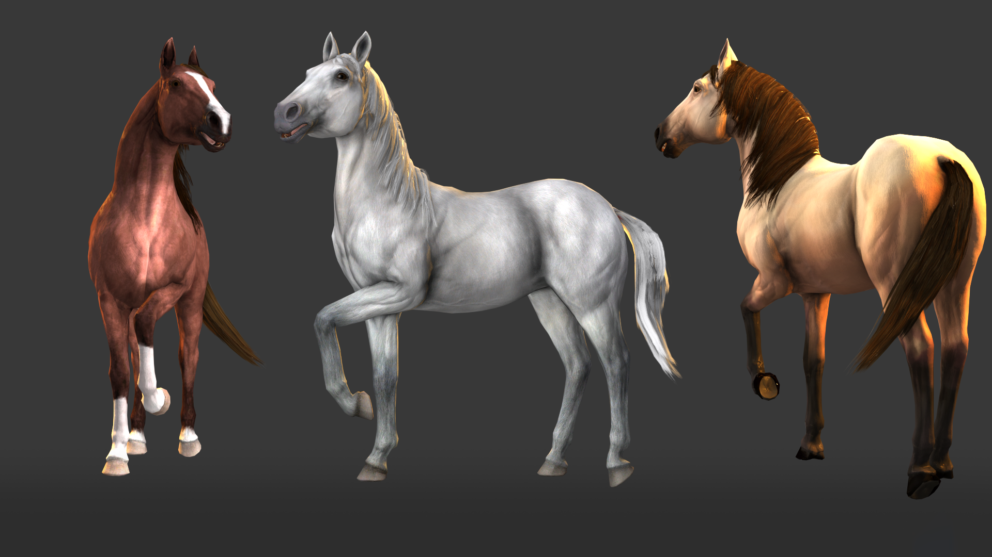



## 

## Rider

Rider…. (pngs)

## Western Wagon

The wagon(pngs)

## Weapons

The weapons(pngs)

Index

# Quick Setups

## General Integration Guide (Riding only)

If you have your own Character Controller or some 3rd Party Controller from the store you will need to do the following steps:

1. Add the ***MRider*** script to your character controller.

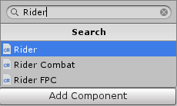

1. If you are using a custom **Input System** you need to connect *MRider.MountAnimal()* to your **Mount Input** and *MRider.DismountAnimal()* to your **Dismount Input.** If you want to continue using my **Malbers Input** then use the Context Menu **Create Mount Inputs.**

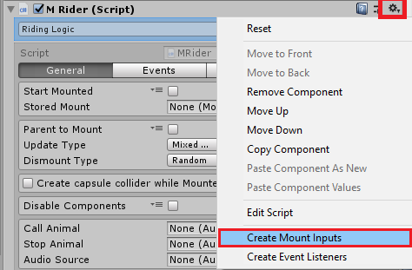

This automatically creates the **MInput** Script and the necessary Inputs needed for the Rider and connect them to the proper methods.

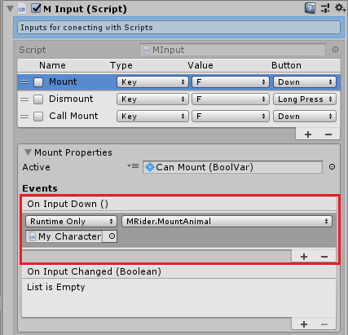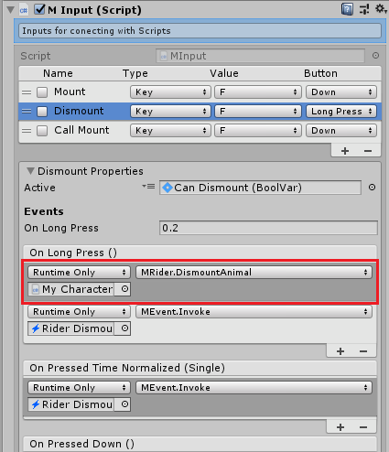

1. If you are using the Riding for mobile then you need to Set the Event Listeners.. This Events are used on the Mobile UI and Mobile Input to communicate with the Rider in a non dependent way. By using the Context menu **Create Event Listeners .**

This will automatically add the ***M Event Listener*** component with the Events needed for the Rider to communicate with external scripts.

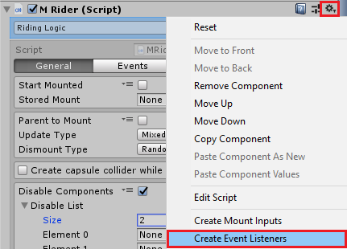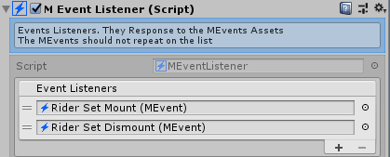

1. Click Add mounted Layer. This will add an extra layer called Mounted and the parameters that the script needs to control the Animator when the character is riding.

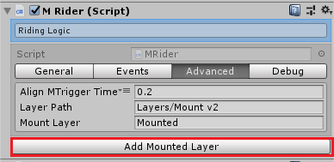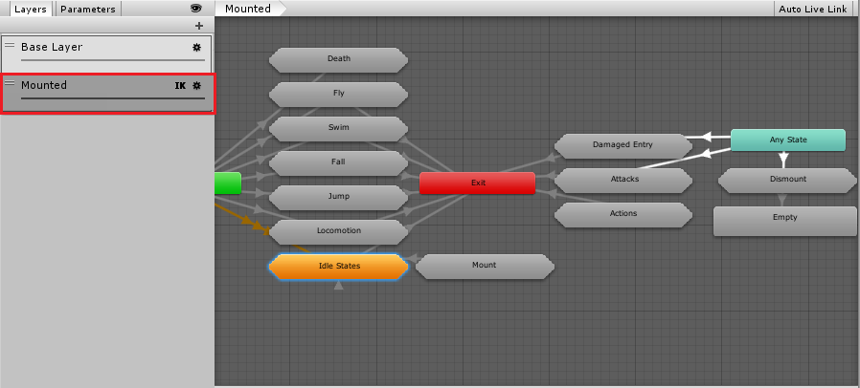

1. On ***Disable Components*** add the scripts that interfere with the logic while riding. (Usually is used for scripts that are not supposed to be active while the character is Riding. Like scripts that move and rotate the character, Ragdoll scripts, etc. Also are used to disable Inputs that are only supposed to be active when the character is not riding: Ex: a Crouch Input).

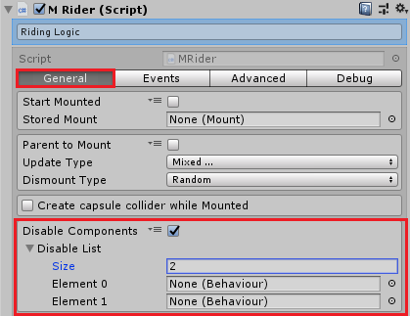

1. Sometimes you will need to disable functions, change variables values when you are Riding the Animal. The best way to solve this is by creating a new Script to communicate between your controller and the Rider Script. You can take full advantage of the Rider Events to let know your character Controller to activate or deactivate behaviours while the character is Mounting or Dismounting the animal. (Ex: Disabling the Crouch Logic of your controller when start the mounting and enabling it back when the character finish the dismount animations).

***And that should be it!.***

## Changing the Model to a custom model

<https://www.youtube.com/watch?v=AZDPZ5id4pM>

(Pending) Make again the Tutorial video.

# The Riding System

Horse Animset Pro is composed by four systems : the [Animal](https://docs.google.com/document/d/1QBLQVWcDSyyWBDrrcS2PthhsToWkOayU0HUtiiSWTF8/edit), the “Montura” (Mount) , the Mount Triggers and the Rider.

Understanding how these systems works will make a much better and smooth use of the asset.

## Animal

This will be the Animal(Horse) or the Western Wagons Horses.

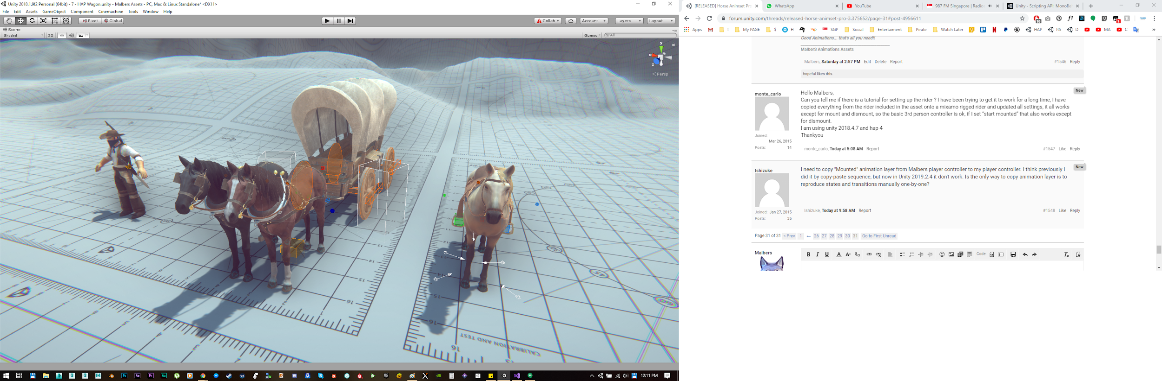

You can check more thoroughly the Animal controller and utility Scripts[**here**](https://docs.google.com/document/d/1QBLQVWcDSyyWBDrrcS2PthhsToWkOayU0HUtiiSWTF8/edit)

* For an animal that is used as a mount, the **Malbers Input** script should be disabled. This component will be enabled when the Rider mounts the animal. That way the animal will only be controlled when is mounted.

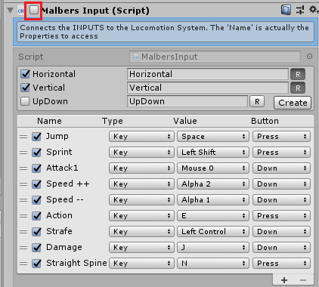

Index

## 

## Mount

This script makes the Animal or creature mountable or rideable. This component is the connection between the Rider and the Animal.

### General:

**Active:**

This option allows this Animal to be mountable. It will be disabled it in case the animal dies, there’s already a rider riding he animal, the wagon is destroyed or in case the rider is not ready to mount this yet.

**Animal:**

Reference of the Animal linked to this Mount. If this parameter is null it will automatically be filled

**ID:**

ID of the Mount… 0 Means is an Animal… 100 means is a Cart/Wagon/Carriage…

This allows the Rider’s Animator to choose the right animations when the rider is Riding the Mount using the *Stance Parameter.*

**Mount Idle:**

The Default Animation of Idle when the rider is mounted. This is used to Identify the Default Idle Animation when the Rider is mounting the Horse.. If you Enable **Instant Mount** the Rider will instantly go to this animation.

**Instant Mount:**

Ignores all the Mounting and Dismounting Animations.



### Links:

Links are extremely important for the Mount System, they are the reference transforms for the rider to mount. They constraint the Rider to be on the Right spot when mounting the Horse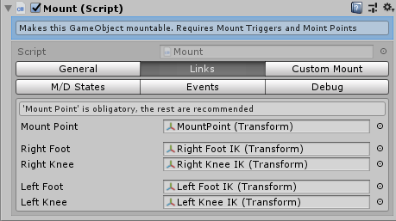

**Mount Point**:

Reference transform the rider will be child of when mounting.

**Left IK**:

Reference transform of the Left Foot for IK.

**Right IK**:

Reference transform of the Right Foot for IK.

**Left Knee**:

Reference transform of the Left Knee for IK.

**Right Knee**:

Reference transform of the Right Knee for IK.

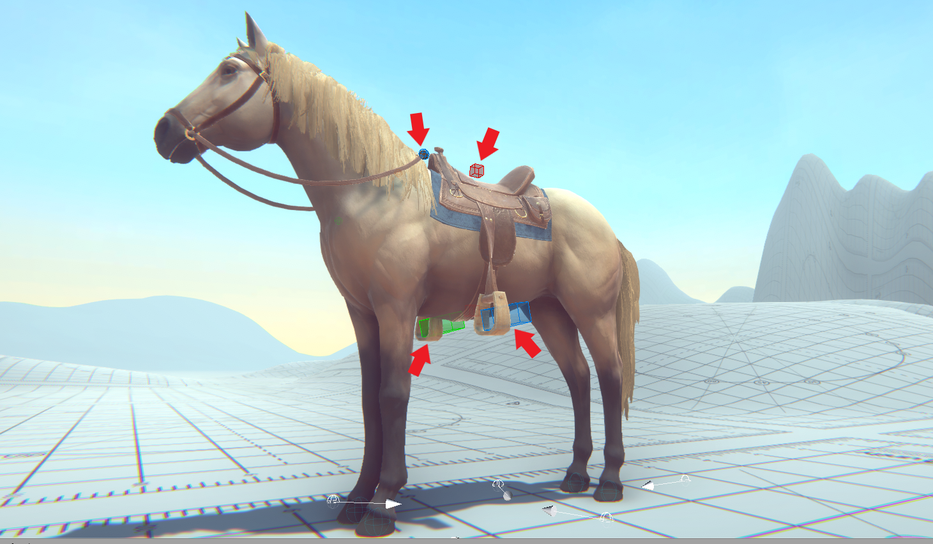

### Custom Mount:

The Mount Animations are made for the horse. When using any other animal, most of the time the animations from the animal and the rider will not match properly. This section is for those custom mounts, for other animals/creatures different from the horse..

**Straight Spine:**

Enabling this option the Rider will ignore the defaults spine rotation of the mount animations, allowing a better sync between the Rider and the Animal.

*This should be enabled for all other animals except the horse.

**Trans Ref:**

Transform to use for the Point Offset Calculation.

**Point Offset:**

Creates a Point using the Trans Ref to Create an Aiming point for the Spine of the Rider using IK.



**Smoothness:**

Lerp value to switch between Straight Spine On and Off

**Animator Speeds**:

Changes the Speed on the Rider's Animator to Sync with the Animal Animator. The Original Riding Animations are meant for the Horse. Only change the Speeds for other creatures.

The Speeds Multiplier list correspond to the animal Speeds Sets.. Mainly for the Locomotion State.

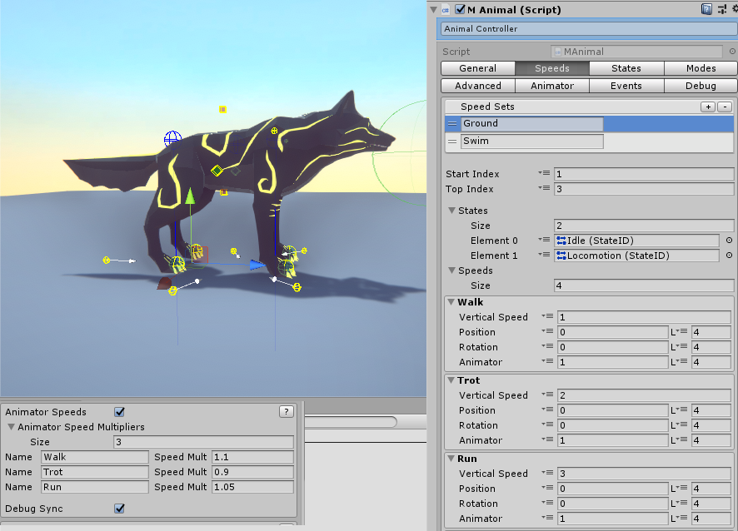

Example: if the Animal is on the Trot Speed Modifier then the Rider will adjust his Animator Speed to match the same length of the Animal trot Animation.

At the moment the Speed multiplier must be change by brute force until you find a good match for syncing the animations. Fortunately there’s a helpful way to guess the best value for the Speed Mult.

On Play Mode you can enable debug and two spheres will appear on the Head of the Rider

### M/D States:

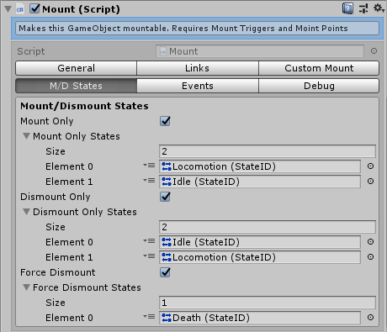

**Mount Dismount States**

Permits the rider to Mount and Dismount when the animal is on an specific state (Idle, Locomotion, Jump.. etc.)

**Mount Only/Mount Only States:**

When enabled, the rider will only mount the Animal when is any of the states on the Mount Only State list. Ex: If we have just Idle, the Rider cannot mount the animal when is moving (Locomotion) or Swimming (Swim).

**Dismount Only/Dismount Only States:**

When enabled, the rider will only mount the Animal when is any of the states on the Dismount Only State list. Ex: If we have just Idle, the Rider cannot dismount the animal when is moving (Locomotion) or Swimming (Swim).

**Force Dismount/Force Dismount States:**

When enabled, the rider will be forced to dismount when the Animal when is any of the states on the Force Dismount State list.

Example: If we have Death on the list, the Rider will automatically dismount when the animal dies.



### Events:

**On Mounted:**

Invoked when the rider start to mount the animal.

**On Dismounted:**

Invoked when the rider start to dismount the animal.

**On Can Be Mounted(Boolean):**

On Dismounted: Invoked when the Mount has an Rider Nearby. By default it has 2 listeners set by default. Using the MEvents *Rider Mount UI*  to let the Mount Interface know that an animal can be mounted and enables the Mount Icon (The **Press F to Mount)**

### Debug:

When enabled it activate the Spine Offset Debug Sphere and the Synchronization Visualization for the Horse and the rider.

Also when playing shows the Internal private variables values.

Index

## 

## Mount Triggers (MT)

Mount Triggers (MT) are the Triggers that let the rider know is near a Mountable animal and he can mount it.

This scripts set all the parameters necessary to activate the mounting animations.

*Mount Triggers* are set on the Layer: *IgnoreRaycast* so they don’t get recognized as part of the animal.

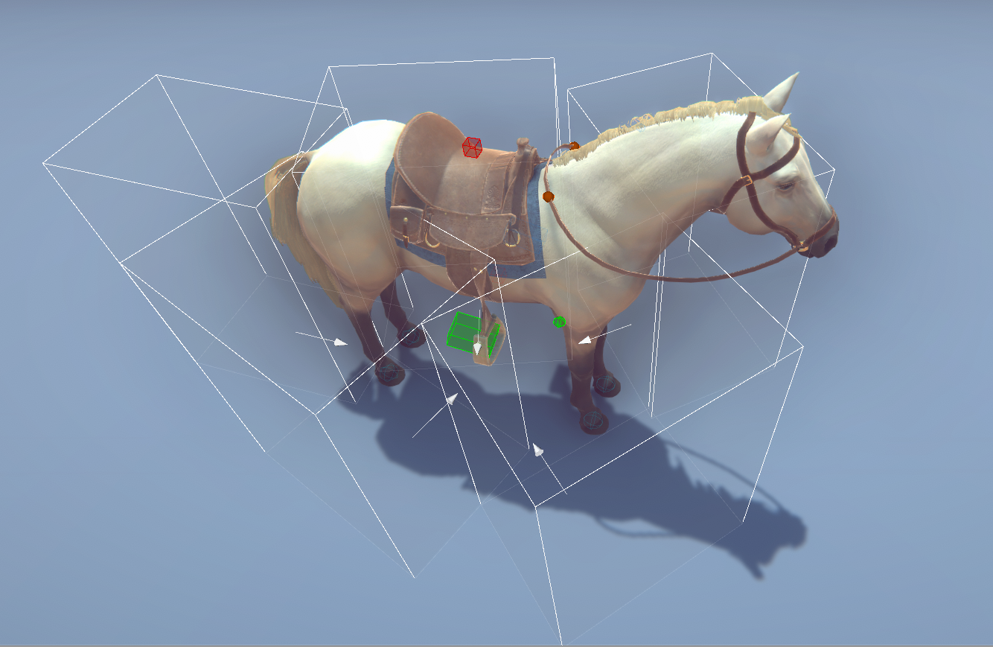

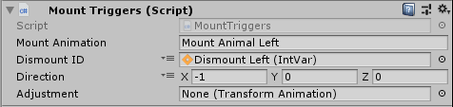

### Parameters:

**Mount Animation**:

Which Animation name this Mount Trigger will send to the Rider when mounting the animal. The name must match with the States. All the Available animations are on the Riders Animator :**Mounted Layer** -> **Mount** Sub-State Machine:

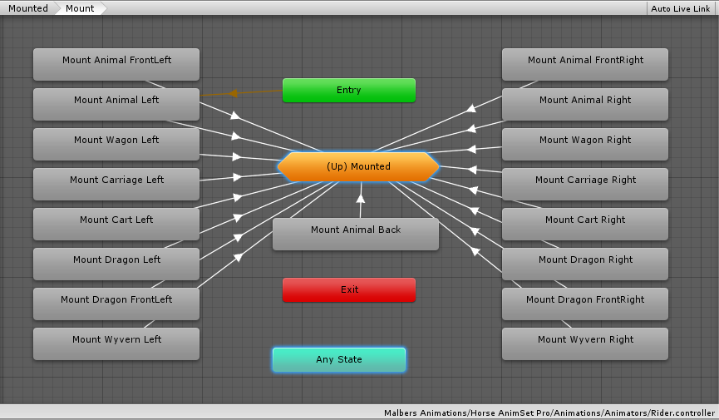

**Dismount ID**:

The value of the **MountSide** parameter for the Animator transitions the MT will send to the Rider when dismounting the animal.

All the **Dismount(MountSide)** Values animations are on the **Mounted Layer** -> **Dismount** Sub-State Machine: Check the *Transitions*.

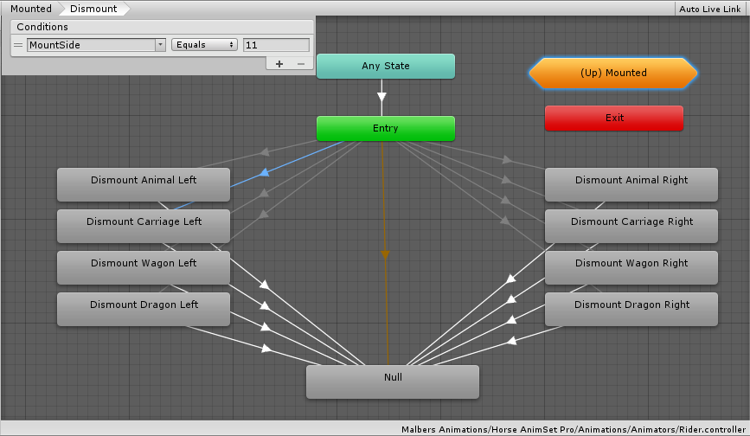

To make life easier the ID is using Scriptables Integers with the values already set:

You can find them in this path:



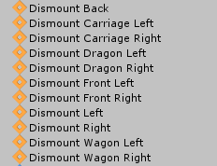

**Direction**:

This value is the Direction the Mount Trigger is relative the Animal.. Example the Left (MT) has a Direction value of (-1,0,0).

This parameter is used by the rider to know where the MT are and dismount properly.

**Adjustment**: 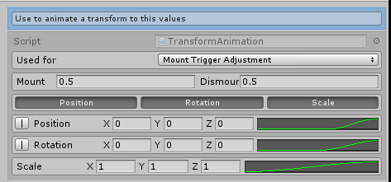

This is used for custom Mounts. The Mount and Dismount animations are made for the horse and sometimes the animals you choose for mounting are smaller/bigger than the horse.. Like a wolf for example. This parameter fix that.. When setting a new Transform animation you can scale the Mount and Dismount animation to fix better the new animal to mount..

In this case the Mount and Dismount animation are scale down to a half.

Index

## The Rider

Horse Animset Pro is meant to be used with a more Advanced Character controller.

This component needs an Animator component and the character Rig needs to be set as an Humanoid. That way it can use the Riding Animations.

The provided character controller is a basic version of the **Third Person Character** from the **Standard Assets.** Is only used as a base Character Movement when is not on the horse.

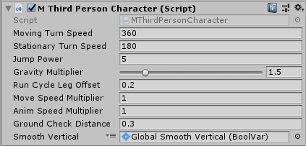

The Rider system is composed by two scripts, the ***MRider*** which is meant to be used for third person controllers and the ***RiderFPC*** which is meant to be used for First person controllers without an Animator Component.

### The Parameters

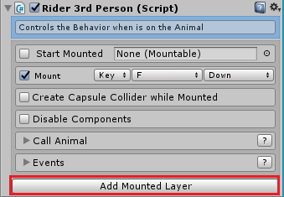

**Start Mounted:**

Check this to start mounted on the horse when you hit play. It needs a mountable stored on the *Mountable Slot.*

**Mountable Slot:**

Apart from being used for the Start Mounted functionality here it will be stored the last animal you mounted. So when you use the ***Call animal*** feature and the Mountable can be called (has AI Mount and a navMeshAgent), this animal will follow you ‘til the end of time!.

**Mount Input:**

Activation for the Mounting System. Which key or Unity Input will be used. Also to be able to activate the Mounting System the Character must be inside a Mount Trigger

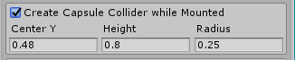

**Create Capsule Collider while Mounted:**

This will create a small collider when the rider finish mounting the horse and will remove it when start the dismount animations. Use this to hit or collide with the rider while is mounted, since the Rider script will deactivate all the colliders that the character has. In the same gameObject level.

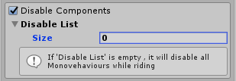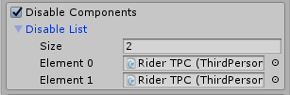

**Disable Components:**

If some scripts are messing up the rider logic, disable them!. If the **Disable List**  is empty, all scripts attached to the character gameobject will be disable, excep*t (Rider3rdPerson, RiderTCP* and  *RiderCombat)* while riding.

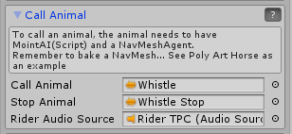

**Call Animal Feature:**  To call an animal , the animal needs to have ***MountAI****(Script)* and a ***navMesh Agent*** attached to it. Remember to bake the NavMesh. See Poly Art Horse as an Example.

### Events:

**On Start Mounting:**

Invoked when the rider start the mount animation.

**On End Mounting:**

Invoked when the rider finish the mount animation.

**On Start Dismounting:**

Invoked when the rider start the dismount animation.

**On End Dismounting:**

Invoked when the rider finish the dismount animation.

**On Find Mount:**

Invoked when the rider found something to mount.

**On Already Mounted:**

Invoked when the option Already Mounted is activated.

This event are extremely useful. Things like change the camera to follow the horse when the rider mount the animal and back to the rider when dismounting; or show an UI to let the player knows to “Press F to Mount”...can be set here with no extra lines of code.

**You can add listeners to this events via code to integrate your controller with the riding system.**

Index

### Quick Notes

When the riding system is activated with the mount input the rider pivot is changed to the center of the character instead of the feets. The reason for that is all the riding animations

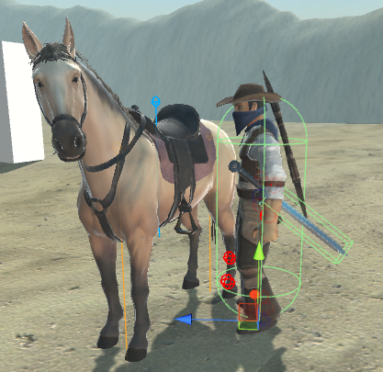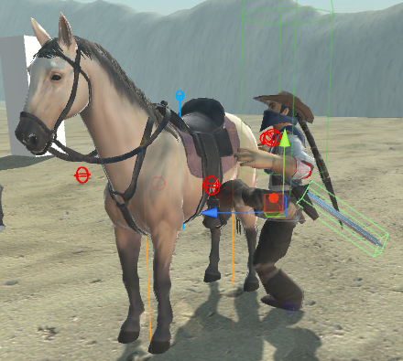

So when mount/dismount animations are played; the mounted layer gets activated and on the Animator… the ***Mount/Dismount Behaviours*** are executed. They are in charge of seamlessly rotate and move the rider to the mount trigger pivot so the rider looks at the horse for mounting , and changes from your controller to the riding system.

Index

## 

## Rider Combat (Combat System while riding)

The combat system is managed by the ***Rider Combat*** *(Script).* This script manages the store/draw - equip/unequip weapons that you want to use while riding. In order to the weapons get recognized by the rider combat script, they need to have the***IMWeapon*** Interface on it. The fastest and easy way to make any of your weapons compatible is simple adding the matching MWeapon Script to it (***MMelee, MBow, MGun***)

### 

### Quick Setup guide *(Rider Combat)*

If you have your own controller or some professional controller from the store you will need to do the following steps. (this can vary depending of your TCP)

1. Add the ***RiderCombat*** script to your character controller.
2. Click Add Rider Combat Layers. (This will add some extra layers and parameters the script needs to control the Animator) (this need to be on top of the mounted layer).
3. Select the layers on the **Hit Mask** you want to interact(hit) while the rider is on *combat mode*.
4. Set the **Inputs** that matches your input system.
5. If your have an inventory set enable **use Inventory.** If your weapons are child of holders enable **use Holders.**
6. Add **Combat Abilities** that matches the weapons your will be able to use while riding
7. Connect the events to your character controller to activate or deactivate behaviours while the character is on *combat mode*.
8. Add to your weapons the ***MWeapons*** scripts to make them compatible with the rider combat system.

### 

### The Parameters

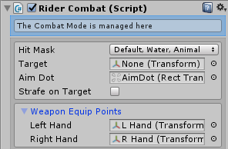

**Hit Mask:**

What layers to hit while riding.

**Target:**

Target the Rider is aiming to. If this is empty the rider will Aim towards the Camera forward direction plus the Aim Dot position on the screen.

**Aim Dot:**

Reticle for the Aiming Weapons.

**Strafe on Target:**

if Target != null the horse will change the movement to Strafe if this option is active.

***Weapon Equip Points:***



This are the position of the left and right hands that the weapons will be child of when a weapon is equipped and ready to make attacks. (TCPs like Opsive and Invector use Equip Points, change this references if is that the case).

***Inputs:***

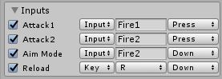

Inputs for activating the Attacks, aim and reload animations. Change the inputs values so they can match your input system in case you’re using some Input Asset from the Store.

*\*\*Attack1 and Attack 2 must be set to* ***Press.***

**Active Holder Side:**

If a weapon don't have a holder to be unsheathe from..(if is set to None), this will be the default holder. (which is responsible to play the draw/store animation).



**Use Inventory:**

This is commonly use when your weapons are managed by an Inventory system.

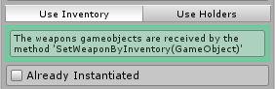

**Already Instantiated:**

If ***True*** If the weapon is already instantiated before entering the rider combat. If ***false***, the rider combat will do the instantiation of the weapons gameobjects.

***Use Holders:***

Use this if the weapons are child the holder game objects. (See HAP TCP (Holders) Sample Scene )

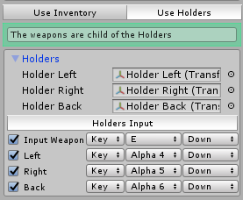

**Holder Left:** Reference for the Left Holder Transform

**Holder Right:** Reference for the Right Holder Transform

**Holder Back:** Reference for the Back Holder Transform

**Input Weapon:**  Input for storing drawing the current weapon

**Left:** Input for Draw/Store the Left Holder Weapon

**Right:** Input for Draw/Store the Right Holder Weapon

**Back:** Input for Draw/Store the Back Holder Weapon

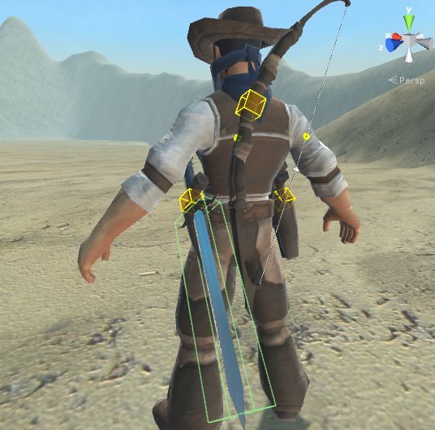

Here’s a representation of this holder on the cowboy, this are aligned to “sheathe” the weapons in a fancy way. Using coroutines, I align smoothly the weapons to the hand of the player and back to the holders when they are stored.

The visualization of empty gameObjects are made using a utility script called ***GizmoVisualizer*.**

**Rider Combat Abilities List:**

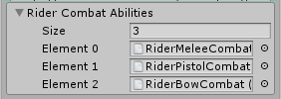

For better modularity the Weapons Abilities are splitted from the ***Rider Combat*** Script so you don't have unnecessary Abilities in your game if you don’t need them, or the third person controller you are using does not support it. So Melee, Bow and Pistol combat are separated asset created from scriptable objects that you can include it through the combat Abilities list.

This Abilities manage the Animation for this type of weapons.

Melee Weapons -> ***RiderMeleeCombat***

Bow -> ***RiderBowCombat***

Pistol -> ***RiderPistolCombat (IK/FK)***

*On future Updates I will keep adding more abilities like Spear, throwables, Rifles, Magic Staff,....*

**Events:**

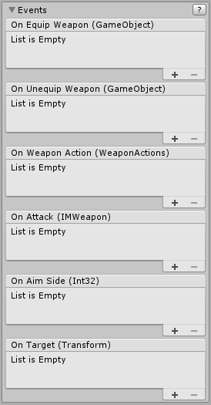

**On Equip Weapon**:

Invoked when the rider equip a weapon.

**Unequip Weapon**:

Invoked when the rider unequip a weapon.

**On Weapon Action**:

Invoked when a new ***WeaponAction*** is set.

*This are the weapon Action*

*.* 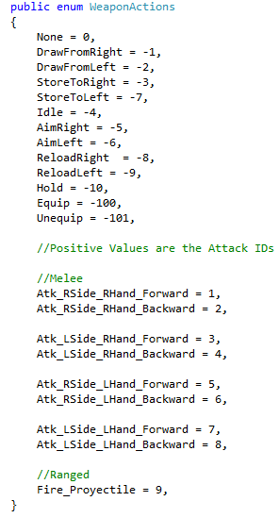

**On Attack**:

Invoked when the rider is about to Attack(Melee) or Fire(Range).

**On AimSide:**

Invoked when the rider is Aiming.

***1:*** *The camera is on the Right Side of the horse;*

***-1:*** *The camera is on the Left Side of the horse; .*

***0:*** *The Aim is Reseted.*

**On Target:**

Invoked when the Target is changed or gets empty.

## The Weapons

The Weapons Scripts are the link between the rider combat and the weapon from other Character Controllers weapons systems. This scripts uses the ***IMWeapon*** Interface so if you don't want to use the ***MWeapons*** Scripts you just need to implement that interface on your weapon script.

### Common Properties:

### 

**Weapon ID:**

Unique ID of a weapon which is used to identify when we switch into a weapon identify if we are switching into a different weapon.

**Damage Range:**

Random damage this weapon can do between two values, (In case of weapons that can ***hold*** the attack --*Bow--,* damage amount will depends of the he time of holding in case of the bow)

**Force Range:**

Random Force between two values this weapon can apply to rigid bodies (In case of weapons that can ***hold*** the attack --*Bow--,* Force amount will depends of time of holding)

**Right Hand:**

True: the Weapon is Right Handed False: the weapon is Left Handed.

**Holder:**

This will tell the Rider Combat which Holder Draw/Store Animation this weapon should play.

**Offsets:**

The offset of the weapon when is parented to the Hand. If the Character controller uses Equip Points instead , leave this on the default values.

**Sounds List:**

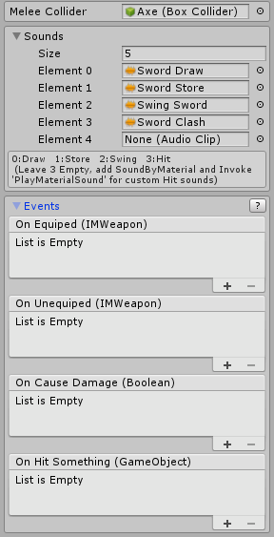

This have a list of sound that is invoked from the Animator using Message behaviour to play a specific sound in time on a weapon animation. (All weapons have the help to show you which sound set on each index of the list).

**Events:**



**On Equipped:**

Invoke to let this weapon knows that it has been equipped

**On Unequipped:**

Invoke to let this weapon knows that it has been equipped

All Weapons Scripts inherit from the MWeapon and gets the properties explain above.

## MMelee

It uses the IMelee interface which inherit from IMWeapon interface.



It requires a Collider (Trigger) to make contact with the objects you want to hit. If the weapon has a ***RigidBody***, set *isKinematic*  to *true*, and Set the constraints to *FreezeAll*.



***On Cause Damage:***

Invoked when the Melee weapon can cause damage which is set by the animator and sent via the *Message behaviours*.

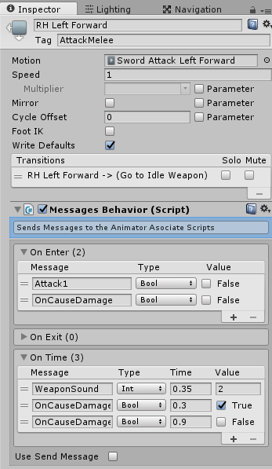

**On Hit Something:**

Invoked when the weapon collides with an object of the same layer setted it on the ***Hit mask***on the rider combat script.

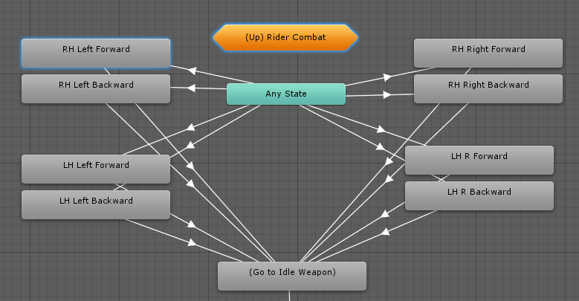

## MGun

## It uses the *IGun* interface which inherit from *IMWeapon* interface.

### 

**Is Automatic:**

If the weapon is automatic.

**Ammo in Chamber:**

Current ammo on the gun chamber

**Ammo Total:**

Total of ammo for the gun, Plus the AIC

**Clip Size:**

Capacity of the gun chamber

**Bullet Hole:**

Reference for the bullet hole prefab to instantiate when hit something.

**Bullet Hole Time:**

Life of bullet hole prefab.

***Events***

**On Fire Gun:**

Invoked when the weapon is fired.

**On Hit Something:**

Invoked when the “bullet” hit something.

**On Aiming:**

Invoked when the weapon is aiming.

**On Reload:**

Invoked when the weapon reloads.

## MBow

***MBow*** script uses the ***IBow*** interface which inherit from ***IMWeapon*** interface.

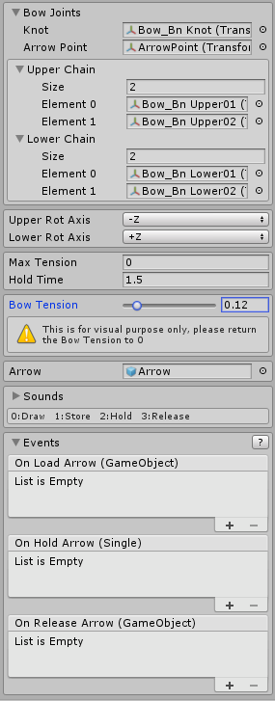

**Bow Joints:**

* **Knot:** The Transform reference for the string point to draw the string when an arrow is set.
* **ArrowPoint:** Rest position for the arrow head. Later the arrow will be aligned between the know and the arrow point.

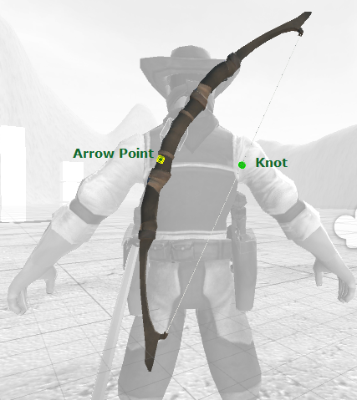

**Upper/Lower Chain:**

Reference for the Bow Bones to bend it procedurally.

**Upper/Lower Rot Axis:**

Axis to bend the upper/lower chains of the bow procedurally.

**Max Tension:**

Max angle the bow can be bent.

**Hold Time:**

Time to stretch the string to the Max Tension

**Bow Tension:**

The normalized Bow Tension (change the value on the inspector so see it how it bends)

**Arrow:**

The arrow prefab to shoot

**On Load Arrow:**

Invoked when the Arrow is Loaded

**On Hold Arrow:**

Invoked every time the Bow tension changes (from 0 to 1)

**On Release:**

Arrow: Invoked when the arrow is released

## MArrow

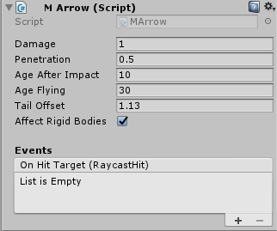

**Damage:**

Damage Multiplier of the Arrow.

**Penetration:**

How much the arrow penetrates after impact.

**Age After Impact:**

The Life of the Arrow after the impact.

**Age Flying:**

Age of the Arrow flying (In Case the Arrow flies off the map destroy after 30 seconds.

**Tail Offset:**

The distance between the Arrowhead and the Tail

**Affect Rigid Bodies:**

if this arrow can affect rigid bodies

**On Hit Target:**

Invoked when the arrow hit something.

The arrow pivot should be on the head, and also the arrow should be oriented in the Z axis forward direction

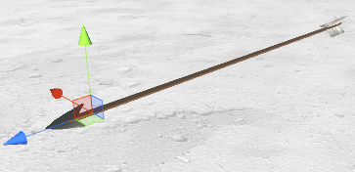

## 

## 

## The Extras

**Cloth Sim**

For Realistic simulation, the reins and mane have Cloth components attach to it to simulate rope and hair, although is a little bit performance heavy, so if you're aiming to a lower performance device you should disable this component

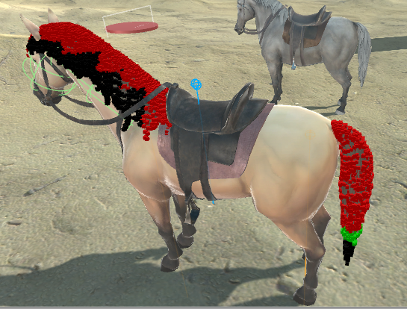

## Step Manager & Step Triggers

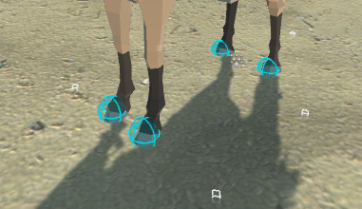

This is a basic foot track system to create tracks and dust on the terrain, and play sounds using triggers on the feet of the horse. The tracks is one particle system which spam particles and play a track sound every time the triggers touch the ground,

The step trigger will search for the Step manager on the root of the game object and let him know that a step has been made.

## IK Reins

If the Animal has the IK Reins (Script )on it, the transforms for the left and right rein will go to the middle of the hands of the rider when riding.

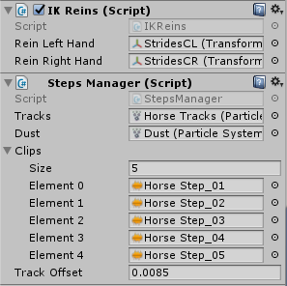

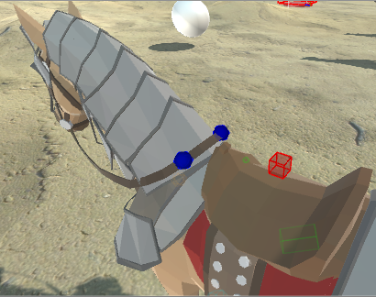

## 

## 

## Mobile Controls

Unity AssetStore updated the UAS Politics on the last quarter of 2016, and since then, we as a publisher cannot include the Standard Assets. So, for the mobile sample scene in order to work; you will need to import ***CrossPlatformInput*** from the Assets Menu.

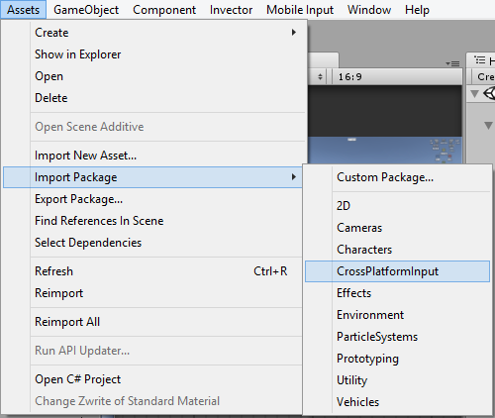

After importing the package, change your platform to **Android** or **iOS** on the ***Build Settings*** and make sure you have the **SDK** installed and don’t forget to ***Enable*** the Mobile Input after change the platform, it should work right on the Editor.

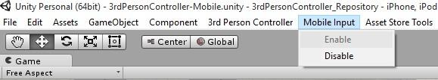

## Utility Scripts

[***Check all Utilities Scripts here***](https://docs.google.com/document/d/1NBy_RQan4Snv6loWhjRZH5UA7jPw6T2JeZiCikCfuSI/edit#heading=h.xvqvp3sepase)